CAMA Requirements

Vermont Dept. of Taxes
Property Valuation Review
VT PIE Project

Version 3.5
2024 UPDATE

Prepared by:
VTPIE Project Team

Contents
Document Versioning 3
Executive Summary 4
Overview 5
Schedule at a Glance 6
CAMA Requirements 7
Parcel Maintenance 7
Business Personal Property 9
Homestead 9
Current Use 10
Grievance 10
Data Exchanges 11
Regular Exports to VTPIE 11
CAMA Export 11
Assessment Report Reference Tables 14
VTPIE Imports 15
One Time (transitional) Imports/Exports 15
Districts 15
Inactive Parcels 15
Spans 15
TIFS 15
Exemptions 17
Appendices 18
Appendix A – Sample Land Allocation for excluded land as separate pacel 18
Appendix B – Sample Land Schedule 19
Appendix C – Sample Scenario 20

Document Versioning

Version | Date | Author | Notes
1.0 | 11/23/20 | Axiomatic | First Draft
1.5 | 1/5/21 | Axiomatic | Second Draft
2.0 | 3/3/21 | Axiomatic | Updates
2.5 | 4/13/21 | Axiomatic | Incorporating feedback from Christie Wright and Cy
2.6 | 4/26/21 | Axiomatic | Minor updates from DA meeting
2.7 | 5/11/21 | Axiomatic | Minor updates
3.0 | 7/1/21 | Axiomatic | Incorporating CAMA Export Schema Draft
3.1 | 8/17/21 | Axiomatic | Updated typos, added schedule at a glance
3.2 | 11/17/21 | Axiomatic | DA Updates
3.3 | 1/21/22 | Axiomatic | DA Updates
3.4 | 1/27/2022 | Axiomatic | Finalize updates: activating inactive contiguous parcels, maintain multiple address for merged parcels, clarification of current use language. Removal of sales upload due to lack of accurate book/page in PTTR information.
3.5 | 2/9/2024 | Catalis | 2024 Updates:  - Add Tax Status Field to CAMA Export  - Add Insurance Value Field to CAMA Export  - Remove unused fields from CAMA Export

Executive Summary
The proposed future state integrates the state’s Integrated Property Tax Management System (IPTMS) web application called Vermont Property Information Exchange (VTPIE) and municipal Computer Assisted Mass Appraisal Software (CAMA) platforms to provide a linear data management process for property taxation. Local assessors and listers will maintain their municipalities property rolls (real and personal ownership and valuation information) within their local CAMA. The municipality will send data updates into the VTPIE system where they will manage their tax program information (homestead enrollment, exemptions, current use, and TIF districts). The CAMA updates combined with the tax program information will be used to generate the municipal and education (delineated by homestead and non-homestead) Grand Lists, as well as municipal and education tax bills.
The processes of reappraisal review, sales ratio study and equalization (CLA calculation) will also be managed within VTPIE . Municipal assessors and listers will validate sales and submit them for PVR audit and review through VTPIE (not VTax). Both local and state users will be able to create ratio studies however, only state ratio studies will be eligible to finalize, and proceed into the equalization calculations. The state processes culminate with the generation of the preliminary and final state education tax rates. The municipal process continues within VTPIE to create and manage both municipal, education, and district (village, fire, police, etc.) billing. VTPIE generated bills may be printed, and billing data loaded into local billing and collections software. A graphic representation of the relevant State and Municipal Systems is provided in Figure 1
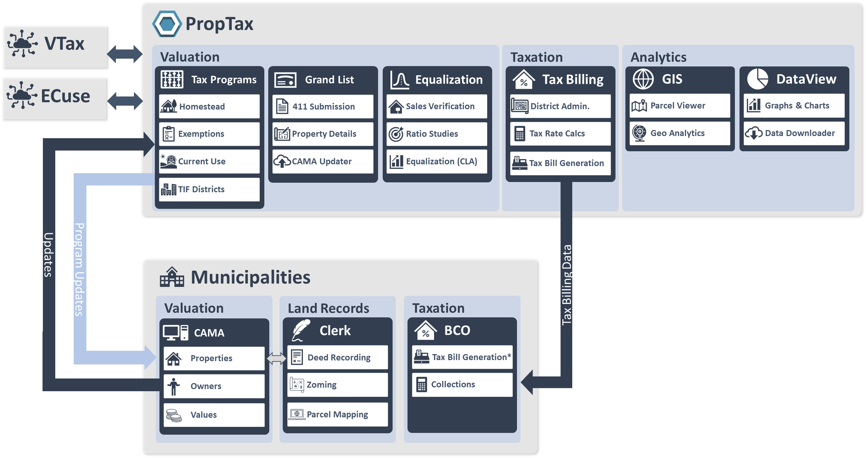
Figure 1: State and Municipal Systems

Overview
One of the primary goals of the VTPIE project is to reduce duplicate data entry and consolidate workflows for municipal and state users. To accomplish this, we must clearly delineate the system of record for each piece of property tax data.
The future state draws clear delineations among the different activities in the property tax workflow, data maintainers and the system of record as listed in Table 1. The two primary deviations from the existing data management process are the shifting of parcel maintenance (transfers/splits/merges) and generating School Property Account Numbers (SPANS) into CAMA. Splits, merges and transfers will continue to be initiation through the recording of a deed with the town clerk. The clerk will send the recorded instrument (or sufficient information to locate it) to the assessor or lister to process the necessary changes with CAMA (direct transfer of ownership, split one parcel into multiple or merge multiple parcels into one). For split parcels, the existing SPAN should be assigned with the parcel with the house.
Element | Process | CAMA | VTPIE
Parcel Maintenance | Generation and management of SPAN | X
 | Processing transfers, splits, merges | X
 | Management of contiguous parcels | X
 | Tracking inactive parcels | X
Personal Property | Creating and managing personal property | X
 | Personal Property Exemptions |  | X
 | Personal Property Grievance |  | X
District Management | Village, special, and school Districts | X
 | Tax Increment Finance Districts |  | X
Exemptions | Special |  | X
 | Statutory |  | X
 | Contracts |  | X
Ratio Study/Equalization | Sales Validation |  | X
 | Ratio Studies |  | X
 | Equalization |  | X
Current Use | Review of Current Use Enrollment/Unenrollment/updates (enrolled acreage enrolled buildings) |  | X
 | Updating current use land lines and building exemptions | X
 | Full valuation of excluded land per appropriate land schedule | X
 | Full valuation of enrolled farm buildings with an indicator that they are enrolled | X
 | Full valuation of enrolled land (as full value of original parcel less full value of excluded land) | X
 | Use valuation of enrolled land | X | X
 | Current use grievance |  | X
Homestead | Receiving and reviewing homestead declarations |  | X
 | Homestead and housesite valuation | X
Valuation | Valuation of all taxable and exempt (insurance value) real and personal properties | X
 | Allocating homestead/non-homestead values | X
 | Valuing covenant restricted housing | X
 | Grievance management |  | X
Grand List | Export of ownership, valuation for real and personal property per 32 V.S.A. § 4152 | X
 | Creation of Grand List (applying exemptions) |  | X
 | Submission of Grand List |  | X
 | Creation of Form 411 |  | X
Education Tax Rates | Generation of education tax rate |  | X
Tax Management | Configuration of billing |  | X
 | Homestead property tax credits |  | X
 | Tax bill generation |  | X
 | Tax bill adjustments |  | X
Table 1: System of Record for Grand List Tasks
To realize efficiencies and reduce the duplication of effort it is necessary to designate which system is the authoritative source of data, and what applications that information is consumed by. The primary source of real and personal property inventory and valuation will be the municipal CAMA. Data will be exchanged between CAMA and the VTPIE system such that state and municipal users can carry out their mutual statutory duties in an online connected environment.
The project team will develop a data export format similar in scope to the existing 411 data export generated by the NEMRC Grand List Software. The export will be run from CAMA and transmitted electronically to the state system for integration into the VTPIE Portal. Data may be synced as often as necessary to update parcel records, however it must minimally be uploaded to the VTPIE portal three time annually, (1) once for the abstract, (2) once when values are finalized for the year (Full Value Export), and (3) once when the grievance process and errors and omissions are complete (As Billed Export). Details of the data export/import are contained in Data Exchanges section of this document.

Schedule at a Glance

 | Module | Description | Go-Live
Phase 1 | GIS | GIS mapping viewer including parcel and grand list data with searching and reporting customized for property tax professionals. | Complete
 | Data View | Transparency portal for public access to PVR’s public data sets. This data set will grow as future modules are released. | Complete
 | Sales Validation | Local assessors and listers will begin using the VTPIE Portal to validate their sales in place of MyVtax. Town clerks will continue to utilize MyVTax. | Complete
 | Ratio Study/Equalization | Ratio studies and equalization calculations will be performed by PVR Staff within the VTPIE Portal. | Complete
Phase 2 | Current Use | Current use applications and enrollments for April 1, 2023 will be processed in the VTPIE portal. Records which are not complete for April 1, 2022 will be processed in the existing way. | Complete
 | Exemptions | Exemptions will be imported from the NEMRC Grand List application. Listers will begin managing exemptions for April 2023 within the VTPIE Portal. | February 2024
 | TIF | Tax Increment Finance Districts will be imported from the NEMRC Grand List application. Listers will begin managing exemptions for April 1, 2023 within the VTPIE Portal. | February 2024
Phase 3 | Homestead | Homestead applications will be received and processed within the VTPIE Portal. Lister responses will be integrated to work dynamically with taxpayer services review process. | Complete
 | Tax billing | Tax Billing will be released to create bills for April 1, 2023 valuations. | June 2024
 | Grievance | Grievance management will be included with the billing module and will allow assessors and listers to generate required notices and log results of grievances. | May 2024
 | Utility Valuation | PVR will begin utilizing a new utility valuation model. | September 2024

CAMA Requirements

Parcel Maintenance
To eliminate the need for duplicate data entry, and multiple data exchanges parcel maintenance (splits, merges, direct transfers, management of contiguous parcels, and generation of SPAN numbers) will occur within CAMA. Business requirements are outlined below.
No | Requirement | Notes
PM-1 | Ability to split records from one to many and maintain SPAN on portion with the house. | Including maintaining Parcel history/lineage  Ability to assign site improvements and outbuildings to each portion
PM-2 | Ability to merge records from many to one | Including maintaining Parcel history/lineage.  If parcels are being merged because they are contiguous indicate on inactive parcels which active parcel they were merged with
PM-3 | Ability to process an ownership change due to a deed | Including maintaining Parcel history/lineage.  Ownership changes should not change SPAN  Ability to warn users if closing date is in the incorrect tax year (e.g. after April 1).
PM-4 | Ability to assign and manage unique SPAN Numbers for each active and inactive record | 3-digit town code, 3-digit school code, sequential non-repeating ID XXX-XXX-XXXXX  Note: must be able to accommodate multiple school districts.
PM-5 | Ability to import existing active/inactive SPANS from NEMRC Grand List Software (one time transfer for cut-over) | Parcels and SPANS are inactivated when contiguous parcels are merged. They may be re-activated if the merged parcel sells. Inactive SPANS include the Active SPAN to which they are linked.  Ability to communicate Inactive parcels to VTPIE with every sync  SPANS of active parcels should be maintained in the CAMA
PM-6 | Ability to manage contiguous parcels | Contiguous parcels with identical ownership are combined. Combination is done by inactivating all but one parcel and updating the activate parcel with land/building attributes.  Active SPAN must be the one with the dwelling (if multiple, must stay with primary or whichever one homestead was declared on).  Contiguous parcels should be valued according to highest and best use. For example if a commercial parcel is merged with a residential separate valuations may be created for each ‘card’.  Desirable: ability to merge values, ability to clone sections for addition to parent parcel.
PM-7 | Ability to inactivate contiguous parcels
PM-8 | For inactive contiguous parcels ability to track active contiguous parcel to which it is associated and an indication that it is inactive due to being contiguous. | Searchable via SPAN (required)  or parcel ID (optional)
PM-9 | Ability to maintain SPAN for inactive contiguous parcels
PM-10 | Ability to activate inactive contiguous parcels | If an inactive contiguous parcel sells it becomes active again. This requires maintenance on the parent parcel to remove land and improvements and return them to the newly active parcel.  Desirable to prompt user to perform maintenance when an inactive parcel in re-activated.
PM-11 | Ability to maintain non-taxable real property
PM-12 | Ability to import non-taxable property from NEMRC Grand List if not already maintained in CAMA | One-time exchange at the time of conversion
PM-13 | Ability to maintain an owner code | T (Town resident), S (State resident), N (Out of state resident), C (Corporation)
PM-14 | Ability to import owner code from NEMRC if not in CAMA | One time import
PM-15 | Ability to maintain taxable status | Taxable, Non-Taxable, State Owned
PM-16 | Ability to maintain special districts (assigned, school districts, special districts, villages etc.) | School district is necessary to develop the SPAN.
PM-17 | Ability to maintain town parcel ID Numbers | Map/Block/Lot etc.
PM-18 | Ability to track Safe At Home Status | (for address redaction)
PM-19 | Ability to maintain category code per state approved list
PM-20 | Ability to restrict deleting of parcels | Inactive parcels should not be deleted
PM-21 | Ability to maintain multiple situs (E-911) addresses per parcel | For merged parcels ability to maintain multiple addresses the original parcels that have distinct addresses.

Business Personal Property
For municipalities with a personal property tax, personal property records should be maintained within CAMA and submitted to the state annually for generation of tax bills.
No | Requirement | Notes
PP-1 | Ability to maintain personal property records
 | Ability to delineate if personal property is Equipment (E), Inventory (I), or Cable (C)
PP-2 | Ability to maintain ownership and mailing address for personal property
PP-3 | Ability to store values for equipment, and inventory personal property | Equipment Value, Inventory value (as filed on PP return)
PP-4 | Ability to store values for cable personal property | Note: Cable is exempt on municipal grand list and taxable on education.

Homestead
Homestead applications will continue to be submitted to the state and will be available for validation and download within the VTPIE platform.
No | Requirement | Notes
HS-1 | Ability to generate homestead and housesite values with ability to have multiple housesites | Up to first two acres constitutes housesite
HS-2 | Ability to generate housesite values | First two acres constitute housesite. It is desirable to be able to generate multiple housesite values.
HS-3 | Ability to indicate which buildings are included or excluded on homestead/housesite | Note: Only one house can be on the housesite.  Two houses may be included in homestead if there is no rental of the second.
HS-4 | Ability to indicate which improvements are included in homestead and each housesite
HS-5 | Ability to apportion valuation into homestead and non-homestead | Apportionment by percent filed on the HS-122 form. Data in VTPIE portal.  Note: Apportion primary dwelling valuation only

Current Use
Current use applications will continue to be submitted to the state through eCuse. Current use validation and enrollment will be managed within the state VTPIE PropTax Portal.
No | Requirement | Notes
CU-1 | Ability to maintain use values for enrolled current use land | Land valued at state dictated $/Acre. Official values presented in VTPIE portal
CU-2 | Ability to delineate enrolled buildings | Enrolled buildings will be fully exempt in VTPIE
 | Ability to maintain full values for excluded (not enrolled in current use) land | Land schedule dictated by actual excluded (not enrolled in current use) Acreage.  e.g. if 10 acres of a 100 acre parcel, the 10 acres is valued at per the 10 acre land schedule.
CU-3 | Ability to maintain total value of enrolled buildings
CU-4 | Ability to maintain original total value of land and value of excluded land to calculate value of enrolled land as a mathematical remainder.  Note: This process is unique to Vermont. | IF parcel contains enrolled and unenrolled land the Full value of the enrolled land is the original value of the original land (prior to use valuation) minus the allocated value of the excluded (unenrolled) land.

Note: PVR and Axiomatic will meet with individual vendors to discuss implementation.

Grievance
Grievances will be managed in VTPIE portal. Users may elect to manage grievances locally or in their CAMA.
If Processed through CAMA, users must export their Change Of Appraisal notices

Data Exchanges

Regular Exports to VTPIE

CAMA Export

Field Name | Description | Reference | Database Field Name | Type (Width)
Status | Records status (Active/Inactive) |  | Status | Text(1)
Tax Year | Tax year of data |  | TaxYear | Text(4)
School Code | School reference code 1-3 characters | School Codes | SchoolCode | Text(3)
County Code | County reference code 1-2 characters | County Codes | CountyCode | Text(2)
Town Code | Town reference code 3 characters | Town Codes | TownCode | Text(3)
SPAN | School Property Account Number |  | SPAN
Tax Entity Code |  |  | TaxEntityCode
Contiguous SPANs | Reference of contiguous SPAN numbers |  | ContiguousSPAN | Text(13)
Parcel ID | Municipal parcel ID |  | ParcelID | Text(50)
CAMA ID | Municipal CAMA account number |  | CAMAID | Text(50)
Ownership Code | Ownership classification code | Ownership Codes | ResidentOwnershipCode | Text(1)
Owner Name 1 | Owner 1 Name |  | OwnerName1 | Text(200)
Owner Name 2 | Owner 2 Name |  | OwnerName2 | Text(200)
Owner Suppressed | Suppressed from public records indicator (Safe At Home) True/False |  | OwnerSuppressed | Text(1)
Mailing Address 1 | Owner mailing address line 1 |  | MailingAddress1 | Text(200)
Mailing Address 2 | Owner mailing address line 2 (Apt. No. etc.) |  | MailingAddress2 | Text(200)
Mailing Address City | Owner mailing address city |  | MailingAddressCity | Text(200)
Mailing Address State | Owner mailing address state |  | MailingAddressState/Country | Text(6)
Mailing Address Zip | Owner mailing address zip |  | MailingAddressZip | Text(9)
Billing Address 1 | Owner Billing address line 1 |  | BillingAddress1 | Text(200)
Billing Address 2 | Owner Billing address line 2 (Apt. No. etc.) |  | BillingAddress2 | Text(200)
Billing Address City | Owner Billing address city |  | BillingAddressCity | Text(200)
Billing Address State | Owner Billing address state |  | BillingAddressState/Country | Text(6)
Billing Address Zip | Owner Billing address zip |  | BillingAddressZip | Text(9)
Category (Real Estate only) | Real property category code | Category Codes | CategoryCode | Text(3)
Number of Dwellings | Number of dwellings |  | NumberofDwellings | Integer
Legal Description | Legal/physical description |  | Legal Description | Text(400)
Situs (E-911) Address 1 | Situs address line 1 (E-911 Address) |  | SitusAddress1 | Text(200)
Situs (E-911) Address 2 | Situs address line 2 (E-911 Address) |  | SitusAddress2 | Text(200)
Situs (E-911) Address City | Situs address city (E-911 Address) |  | SitusAddressCity | Text(200)
Situs (E-911) Address State | Situs address state (E-911 Address) |  | SitusAddressState | Text(2)
Situs (E-911) Address Zip | Situs address zip (E-911 Address) |  | SitusAddressZip | Text(9)
Land Area | Land area in acres |  | LandArea | Decimal(10,2)
Mobile Registration Number | Mobile home registration number |  | MobileRegistrationNumber | Text(100)
Mobile Serial Number | Mobile home serial number |  | MobileSerialNumber | Text(100)
Mobile Model | Mobile home model name |  | MobileModel | Text(100)
Mobile Manufacturer | Mobile home manufacturer name |  | MobileManufacturer | Text(100)
Listed Improvement Value | Listed (full) value of improvements |  | ListedImprovementValue | Integer
Listed Land Value | Listed (full) value of land |  | ListedLandValue | Integer
Listed Total Value | Listed (full) value of improvements |  | ListedTotalValue | Integer
Homestead Total Value | Total value under homestead |  | HomesteadTotalValue | Integer
Non Residential Total Value | Total value under non-residential |  | NonResTotalValue | Integer
Housesite Total Value | Total value under house site |  | HousesiteTotalValue | Integer
Current Use Enrolled Land Value | Value of land enrolled in current use |  | CurrentUseEnrolledLand Value | Integer
Current Use Enrolled Bld Value | Value of improvements in current use |  | CurrentUseEnrolledBldValue | Integer
Current Use Excluded Land Value | Value of land not enrolled in Current Use |  | CurrentUseNotEnrolledLandValue
Personal Property Value | Value of personal property |  | PersonalPropertyValue | Integer
Inventory Property Value | Value of personal property inventory |  | InventoryPropertyValue | Integer
Equipment Property Value | Value of personal property equipment (cable only) |  | EquipmentPropertyValue | Integer
Cable Equipment Value | Value of cable equipment |  | CableEquipmentValue | Integer
Covenant Restricted | Percent of property that is covenant restricted |  | CovenantRestricted | Decimal(3,2)
Last Reappraisal date | Date of last reappraisal |  | LastReappraisal | Text(2)
Tax Status | Taxable Status, also Termed TNS | Available Options:  T: Taxable  N: NonTaxable  S: State Owned Property | TaxStatus | Text(2)
Insurance Value Indicator | Indication of if the valuation was generated using an insurance value | Available Options:  I: Insurance Value Used  A: Assessed Value | InsuranceValue | Text(2)

Assessment Report Reference Tables

Real Property Codes
Code | Description | Notes
R1 | Residential with less than 6 acres
R2 | Residential with 6 or more acres
MHU | Mobile home un-landed
MHL | Mobile home landed
S1 | Vacation home with less than 6 acres
S2 | Seasonal home with 6 or more acres
C | Commercial
CA | Commercial Apartments
I | Industrial
F | Farm
UE | Utility Electric
UO | Utility Other
W | Woodland
M | Miscellaneous
O | Other | Export must contain the category it should be equalized against.

Owner Codes

Code | Description
T | Town resident
S | State resident
NS | Non-state resident
C | Corporation, partnership, and other entities

VTPIE Imports

One Time (transitional) Imports/Exports

Districts
Import to CAMA or VTPIE

Inactive Parcels
Import to CAMA if Needed

Spans
Import to CAMA if Needed

TIFS
Import to VTPIE
Field Name | Description | Reference | Database Field Name | Type (Width)
P_PROP | see lsprop |  | P_PROP | C(10)
P_SUB | see lsprop |  | P_SUB | C(10)
P_TIFID | TIF ID NUMBER SEE LSSYST |  | P_TIFID | C(1)
P_CONTR | original TIF value |  | P_CONTR | N(9)
P_CONTR2 | MIDDLE original TIF value |  | P_CONTR2 | N(9)
P_NCONTR | new base value |  | P_NCONTR | N(9)
P_NCONTR2 | MIDDLE new base value |  | P_NCONTR2 | N(9)
P_ZERO | Zero New Value |  | P_ZERO | L(1)
P_ZERO2 | MIDDLE Zero New Value |  | P_ZERO2 | L(1)
P_MCONTR | Original Municipal Grand List Value |  | P_MCONTR | N(9)
P_MCONTR2 | MIDDLE Original Municipal Grand List Valu |  | P_MCONTR2 | N(9)
P_MNCONTR | New Municipal Grand List Base Value |  | P_MNCONTR | N(9)
P_MNCONTR2 | MIDDLE New Municipal Grand List Base Va |  | P_MNCONTR2 | N(9)
P_MZERO | Zero New Value Municipal |  | P_MZERO | L(1)
P_MZERO2 | MIDDLE Zero New Value Municipal |  | P_MZERO2 | L(1)
P_TOTL | ORIGINAL TIF ACRES |  | P_TOTL | N(10)
P_CONCDE | see lsprop |  | P_CONCDE | C(1)
P_CVOTED | see lsprop |  | P_CVOTED | D(8)
P_CBEGIN | see lsprop |  | P_CBEGIN | D(8)
P_CEND | see lsprop |  | P_CEND | D(8)
P_CSTATUTE | see lsprop |  | P_CSTATUTE | C(10)
P_CAPPROVE | see lsprop |  | P_CAPPROVE | C(1)
P_CBILL | see lsprop |  | P_CBILL | C(1)
P_SPAN | SEE LSPROP |  | P_SPAN | C(13)
P_TZONE | TIF ZONE (DEFAULT TO 1) |  | P_TZONE | C(1)
P_NEWSPAN | SEE LSPROP |  | P_NEWSPAN | C(13)
P_CD2 | SEE LSPROP |  | P_CD2 | C(2)
P_MEMO | TIF MEMO |  | P_MEMO | C(250)

Appendices

Appendix A – Current Use Sample Land Allocation for excluded land as separate pacel
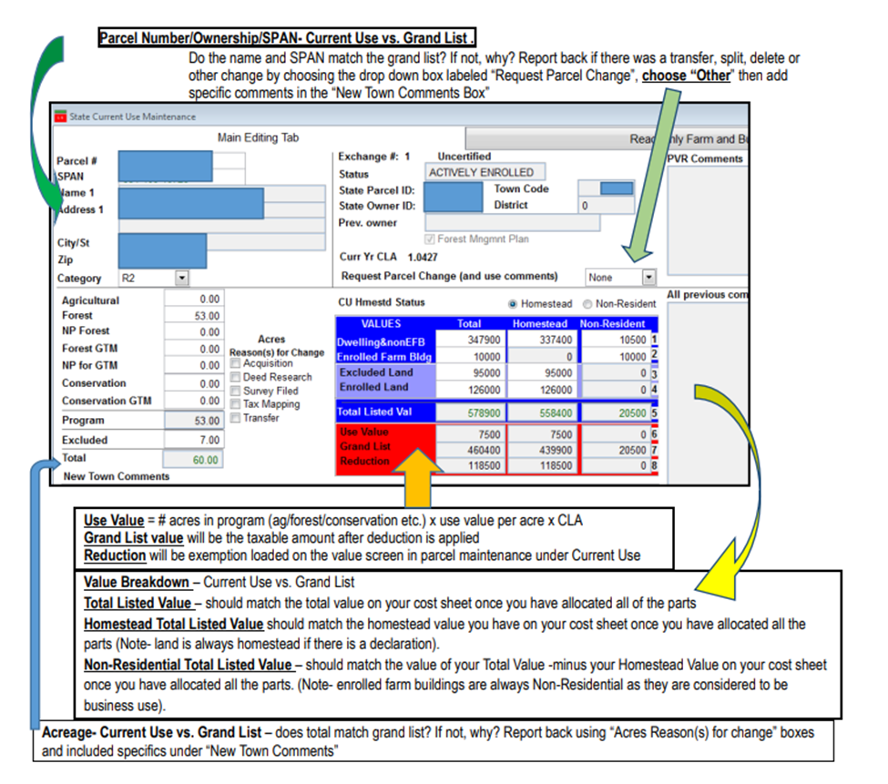

Appendix B – Current Use Sample Land Schedule
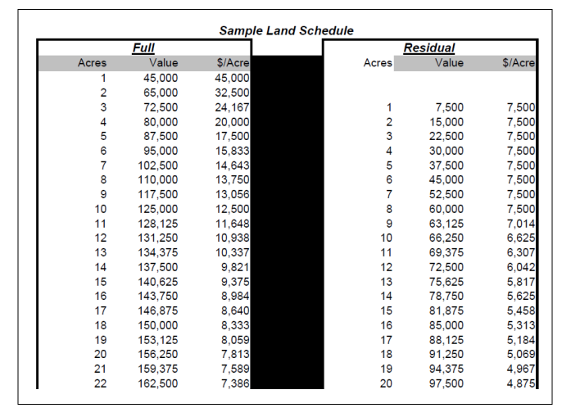

Appendix C – Current Use Sample Scenario
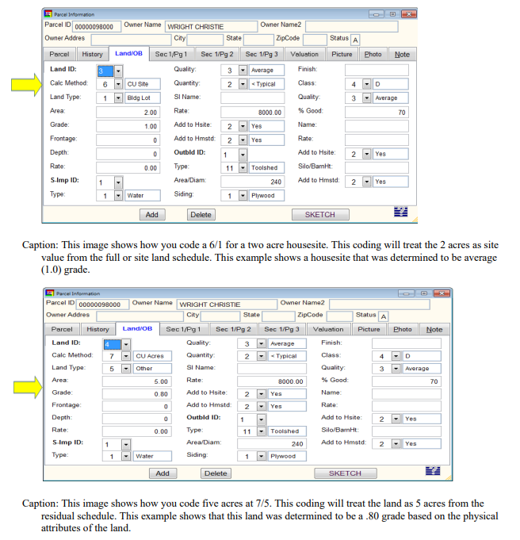
Scenario: A parcel has total excluded land of seven acres. You look at the map and see that two acres is a housesite and five acres is in a corner and is not touching the other two acres. You should value the two housesite acres using a CU Site / building lot coded as 6/1 for two acres at the grade currently applied on the cost sheet. You should code the other five acres as CU Acres / Other coded as 7/5 at an appropriate grade based on your knowledge/research of that portion of land. Account for all factors that affect the grade of that portion of land.

Note that while the deed should not be recorded until the property transfer tax return (PTTR), the PTTR itself does not reflect any change to real property.
Use valuation of enrolled land will be provided in the VTPIE system, however assessors and listers may wish to also maintain the information in their CAMA for completeness.
Note: the abstract is not submitted to the state but must go through VTPIE to be combined with exemptions. Abstract is due June 4th for jurisdictions with a population under 5,000 or June 24th for jurisdictions with a population over 5,000.

